**You have until #:## to complete the following:**

Use the provided variables to generate HTML with PHP. Use a **loop** to loop through the **$posts** variable and generate exactly what is in the image. You can also see this example under “Example 3” at <http://chelmyers.com/php-demo/>.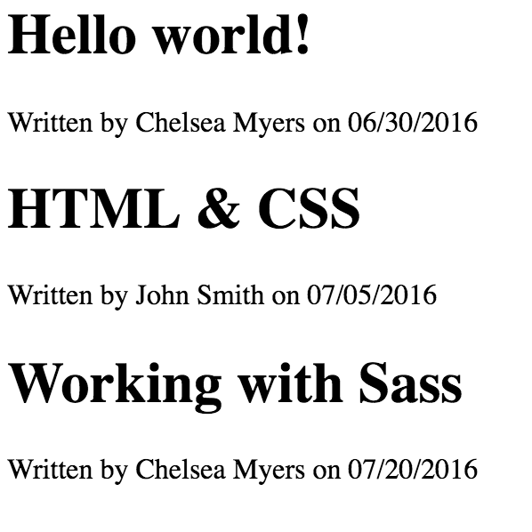

**Google is okay! Use the presentations.**

**This Google doc is also on BBLearn.**

**$post1 = [**

**'Title' => 'Hello world!',**

**'Date' => '06/30/2016',**

**'Author' => 'Chelsea Myers'**

**];**

**$post2 = [**

**'Title' => 'HTML & CSS',**

**'Date' => '07/05/2016',**

**'Author' => 'John Smith'**

**];**

**$post3 = [**

**'Title' => 'Working with Sass',**

**'Date' => '07/20/2016',**

**'Author' => 'Chelsea Myers'**

**];**

**$posts = [$post1,$post2, $post3];**

Raise your hand and show me your work when done.